# Python Coding Challenge Insurance Management System

Name: P217 Mubeena

Outputs

Insurance Management System Menu:

1. Create Client
2. Create Policy
3. Get Policy
4. Get All Policies
5. Update Policy
6. Delete Policy
7. Exit

Enter your choice: **Choosing 1**

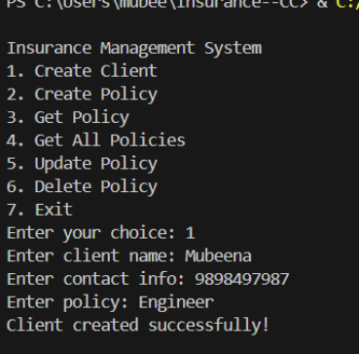

**Data Reflected to the database**

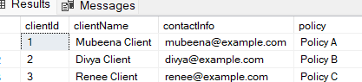

Choosing Option -2

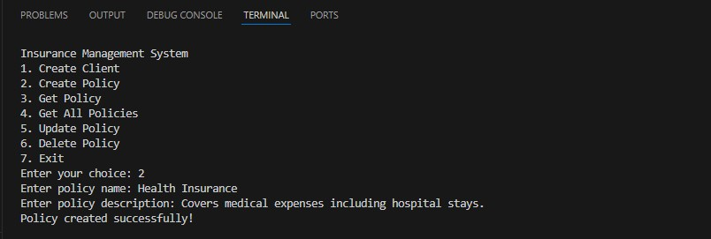

Data Reflected to the Database

*Data added to the database at end*

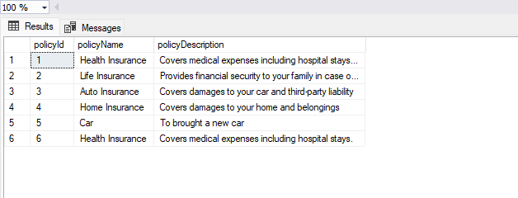

Choosing Option -3

Getting the Policy by entering the Policy ID

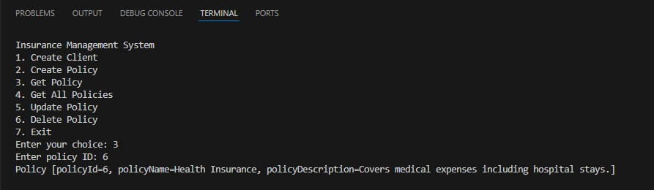

**Choosing Option -4**

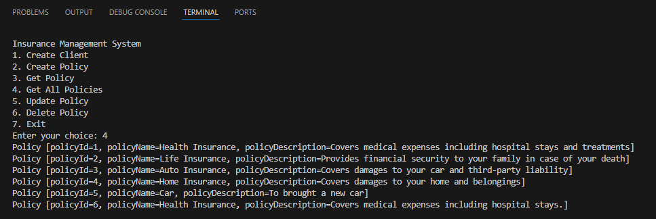

Choosing Option -5

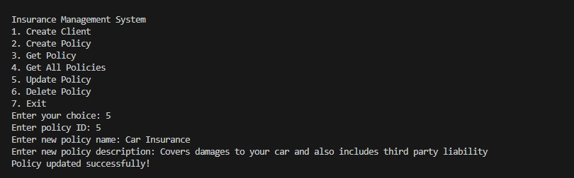

Choosing Option -6

*Enter Policy Id to delete from the database*

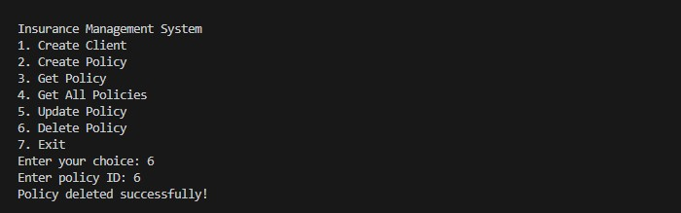

Data Reflected to the database

*PolicyId 6 is deleted from the database*

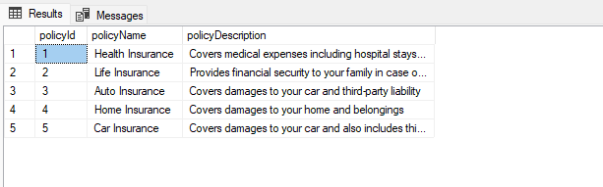

Choosing Option -7

*Exiting from the database*

